PL/SQL EXERCISES

Exercise 1 : control structures
Script output :
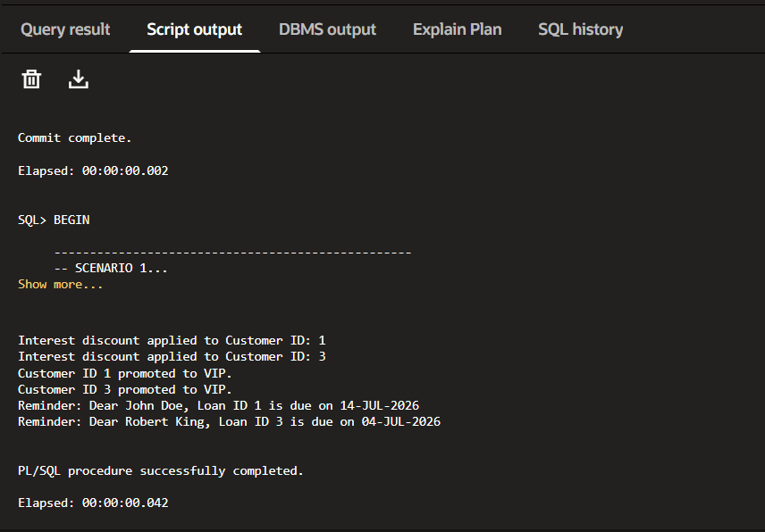

Exercise 2 : Error handling
Script output:
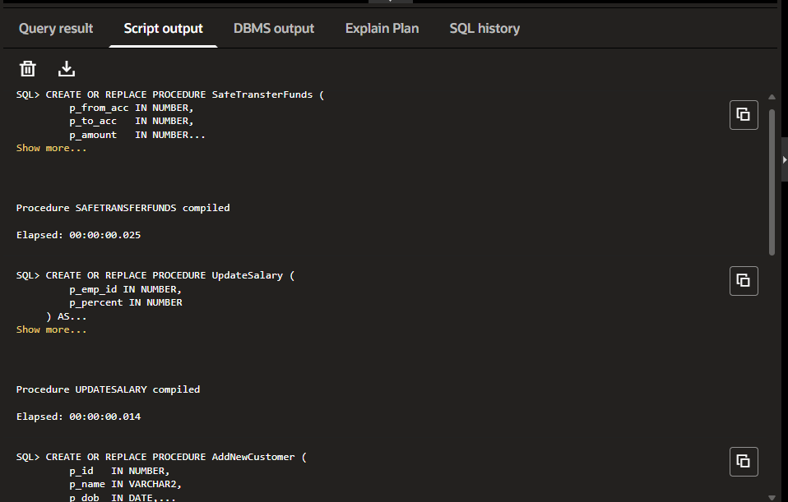
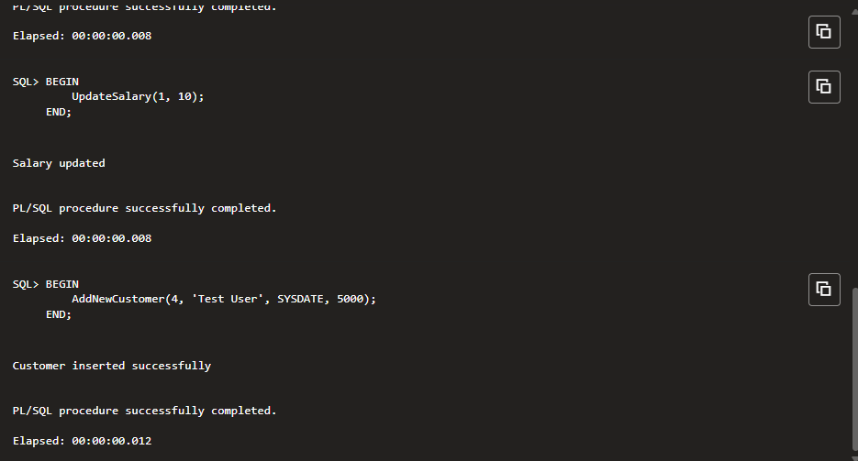

Exercise 3 : Stored Procedures
Script output :
